Introduction to the Beaglebone and GPIO Expanders

**March 23, 2016**

**Team Members:**

Tatiana Ensslin

Connor Kane

Table of Contents

Introduction 3

Methods 3

GPIO with the Beaglebone Using the Command Line Interface 3

GPIO with the Beaglebone using C++ 3

Compare the speed of a Beaglebone GPIO to the KL05 GPIO 4

GPIO Expander on the I2C Bus 4

Using the GPIO Expander with C++ Code 4

Detecting Analog Signals with the Beaglebone 5

Display the Voltage and Number of rotations on the LCD Screen 5

Results 5

GPIO with the Beaglebone Using the Command Line Interface 5

GPIO with the Beaglebone using C++ 7

Compare the speed of a Beaglebone GPIO to the KL05 GPIO 8

GPIO Expander on the I2C Bus 9

Using the GPIO Expander with C++ Code 10

Detecting Analog Signals with the Beaglebone 10

Display the Voltage and Number of Rotations on the LCD Screen 10

Discussion 10

Appendix A- GPIO with the Beaglebone using the Command Line Interface 11

Appendix B – GPIO with the Beaglebone Using C++ 13

Appendix C – Interfacing a Keypad 19

Appendix D – Reaction Game 23

# Introduction

This lab report presents an application of the Beaglebone Black using GPIO Expanders, as well as using a mini USB to connect to the GUI XLaunch. This allows us to see a visual of what we are programming on the Beaglebone. This experiment will focus on using GPIO’s with the Beaglebone through command line interface and C++ code, allowing us to test and compare the speed of GPIO’s on the Beaglebone to the KL05’s, as well as implement a MCP23017 by microchip GPIO expander on the I2C bus of the Beaglebone to detect analog signals in order to display voltage and rotations on an Altera DE2 Board LCD. A GPIO expander stands for general-purpose input/output expander, which allows designers to add extra I/O to their designs by freeing up the microproccesor’s GPIO for other use. This application begins off by getting familiar with the GPIO on the Beaglebone using the command line interface, connecting the GPIO’s using C++ code, comparing he speed of a Beaglebone GPIO to that of a KL05 GPIO, Using a GPIO Expander on the I2C bus and with C++ code, as well as detecting analog signals with the Beaglebone which can allow one to display the voltage and rotations of a potentiometer on an LCD. By the end of the experiment, one will be able to understand GPIO’s on both the Beaglebone and KL05, as well as be able to implement a GPIO expander and use it to collect analog signals. One will also become familiar with the GUI Xlaunch. All code can be seen in the Appendix.

# Methods

## GPIO with the Beaglebone Using the Command Line Interface

For this section, begin by connecting the mini usb to the Beaglebone and open the GUI XLaunch. Create a configuration with a start name of Startlxde connection using PuTTy, with an OP Address of 192.168.7.2, a username of debian, and password of temppwd. Use this to interface eight of the GPIO pins. To test these, connect switches to pins and LEDs to the output pins. Use the Altera board for this task. Use the command line interface on the GUI to browse through the directory tree in Linux in order to read and write the files used by the kernel to control the GPIO. Next, interface eight of the GPIO pins: four inputs (GPIO3_14, GPIO3_15, GPIO3_16,GPIO3_17), and four outputs (GPIO1_18, GPIO2_5, GPIO2_9, GPIO2_10). The inputs are switches. In order to export commands for our pins there is some math that is required. Because each bank is 32 bits large, you must multiple the bank number by 32 and add the offset (bit number). You then need to change the command line user to a super user using Sudo SU, in order to change the direction/value using export. To connect the LEDs, use VHDL and the Altera board using Quartus software. The output pins should connect to the LED pins. A value of 0 means output.

## GPIO with the Beaglebone using C++

Next, design software for the Beaglebone which will implement proper C++ constructs for the purpose of reusability. Code the GPIO methods using proper object oriented design techniques, creating a GPIO class. In order to control the GPIO pins from software, the files modified form the command line must be opened and the modified from C++ code. Remember to close the file so tha the kernel may access the file and change the status of the GPIO pin. If the file remains open, the Linuz kernel will not be able to access it. Write code that will state four input pins status, and writes that state to the four LEDs. This will enable the switches to individually turn on and off the LEDs. Start by creating a new folder under home/debian. Create a header file with protections using #defnif #define #endif. Out .h and .cpp for out GPIO object is under /sys/class/gpio$. Fill the GPIO.cpp with constructors, destructors, setters (value, pin, direction)/getters. Use std::/iostream/sprint to open up pathways to the GPIO folder and event to the selected specific pin. For example, sprintf(bug,”/sys/class/GPIO/GPIO%d/value,”getPin()); It is also important to note that when compiling the code you must define the defined variable that protects the main(). You also must run the code as a sudo user or else you will not be able to export the pin. Use G++ -D to compile and debug the code. After, connect the switches directly to the LEDs to represent a changing value on a switch’s move.

## Compare the speed of a Beaglebone GPIO to the KL05 GPIO

Next in the experiment, you will compare the speed of the Beaglebone to that of the KL05. Even though the BeagleBone runs a Sitara AM3358BZCZ100, 32-Bit, Arm-A8, 1GHz, 2000 MIPS processor and the KL05 runs an ARM-M0+, 32-bit processor clocked at almost 21 MHz, it should still be instructive to compare the speeds. Leave the KL05 at its default clock speed. For the Beaglebone, write a piece of C++ code that uses the previously written GPIO class. The code should run a loop that sets a GPIO output pin high and then low as fast a possible. The pin we chose was GPIO2_9. This will produce a square wave at the output of the selected GPIO pin. Measure the frequency of the square wave in order to determine how fast the GPIO pin can be switched. Write this code for the KL05 as well, and run it and observe the GPIO output square wave. Measure the frequency. Record both frequencies and compare the results.

## GPIO Expander on the I2C Bus

The Beaglebone has a significant amount of input output capability with the two large headers along the sides of the board. When these are used for displays and touch screens, you can quickly run out of I/O pins. For these circumstances GPIO expanders have been developed. Use the MCP23017 by microchip, a two extra 8-bit IO ports connected to the I2C bus. Wire the MCP23017 IC with the proper power, ground, and biasing signals connected. These pins are VDD, VSS, A0, A1, A2, and RESET; connect them to power (+3.3V please) or ground as needed. The address pins A0-A2 help to determine the 7-bit address used on the I2C bus, but don’t worry we will use a Linux utility called i2c-tools to help us find the address. You will also need to connect the I2C communication lines to the Beaglebone; SCL and SDA. Once the GPIO expander is connected to the Beaglebone run the methods in i2c-tools to perform the following tasks: find the GPIO expander on the I2C bus using i2cdetect, use any of i2cdump, i2cset, or i2cget in order to configure and use the GPIO from Linux on the Beaglebone. Be able to determine the I2C address of the GPIO expander as well as be able to change one of the GPIO pins configured as an output to either 0 or 1 and measure it changing using Analog discovery. Also ensure that you can read a different GPIO pins configured as an input when it is connected to ground and then VDD (0 then 1). Use the command Sudo SU; echo BB-I2C1 > $SLOTS. After I2Cdetect –l, we find I2C-2 is created. By writing I2Cdetect –y –r2, we find the slave address of 0x27. Next, use I2Cget and I2Cset to configure our pins as an output. To do this write to GPIOA which register’s value is 0x12 using I2CSet.

## Using the GPIO Expander with C++ Code

For this section, make use of the GPIO expander by connecting it to the LCD screen. The LCD screen on the Altera board requires 8 data lines and 2 control lines in order to implement its protocol. Use the GPIO expander to connect to the LCD. Use the provided I2C class with your code. Then, write a piece of code for the Beaglebone that will implement the standard display test; “Hello” (top line of LCD display) “World” (bottom line of LCD display). To do this, modify the iven code to include three more commands: I2CDevice.Open(); I2CDevice.Write(); I2CDevice.readRegister(); Use the register address and the slave address plus ASCII for each letter of “Hello World” to sync the I2C connection successfully and utilize VHDL with Altera to sync the Beaglebone to the I2C Connection. Note that it is important to Sudo SU CD $DTOS; echo BB-_2C1 > $SLOTS to set up Device Tree Overlay.

## Detecting Analog Signals with the Beaglebone

For this section, analog signals are different than the digital signals in previous experiments. A digital signal can only be zero or one. The Beaglebone represents a zero or one using either GND or 3.3V. Analog signals can have any continuous value between the two reference voltages. On the Beaglebone the analog system uses references GND and 1.8V. If you use a voltage greater than 1.8V, it will destroy the entire board. The Beaglebone’s 1.8V source and GND are at the bottom of its header. Connect 2 outer pins of a potentiometer to these pins. Choose one of the four analog input pins and connect the middle pin of the potentiometer. This process requires Device Tree Overlay to configure the analog to digital converts (for Linux). To do this use Sudo SU; cd $DTOS; ls | Grep BB-ADC; echo BB-ADC > $SLOTS. This process exports the ADC and allows one to create files that let us read the analog voltage set by the potentiometer. Using the I2C connection maintained from the previous section, write a piece of code that continuously loops to display the value of the standard out. The numbers will change reflecting a turn on the potentiometer. Make a function for the analog input. Be sure that you can demonstrate the value contained in the analog file displayed on standard out. Note that CAT ANI0 reads the value of the potentiometer if it is connected to the output voltage pin. Turning the potentiometer clockwise increases the voltage.

## Display the Voltage and Number of rotations on the LCD Screen

To screw the voltage on the potentiometer from ground to 1.8V, it takes 15 full turns. The potentiometer is a 15 turn potentiometer. Using the past previous sections, which utilize the I2C and the ADC to display the voltage, display the “Voltage:” on the top line and “Turns:” on the second line of the LCD. Ensure that the code is continuously running so the actual voltage and turns display in “real time.” To do this, in the C++ code, read a value in form a file for mthe /sys/devian/ocp.3/helper.12/ ANT0 path. We use sprintf to move to this location in the code. Once we open the file for input streaming we read till .eof() and save the stream to a buffer. Then parse the data from ASCII to int. To find the total percentage: turn percentage = 1.8 – input voltage. This means the number of turns can be calculated by: number of turns = total percentage * 15. Once we find the total voltage in volts and number of turns we display the proper formatting. Be able to display the voltage and calculated turns in actual time.

# Results

## GPIO with the Beaglebone Using the Command Line Interface

This section will focus on Output Compare Mode—also know as wasting an exact amount of time. This may be used to connect the Timer Unit Hardware directly to an I/O pin. On the HCS12, the I/O Port T can control the timer. The timer can also be implemented apart from I/O. There are two registers in the Timer Hardware Unit. They are the timer counter resiter (TCNT) and the output compare registers (TCx). There are 8 output compare registers (TC0-TC7), meaning 8 timers can be implemented at a time. When TCNT equals TCx, a flag is set. The steps we used in implementing the timer is as follows:

* Set up the timer by writing to the timer control registers at the beginning of the program.
* Read the 16-bit timer counter register TCNT and add a delay.
* Place the result into the output compare register TCx.
* As an example: TC2 = TCNT + 0x3A58, which configured a delay of 14,936 timer counts on timer 2.
* Wait for the flag to be set. While(!TFLG1_C2F).
* Take note that when creating a repeating delay, the delay should be added to the output compare register. TC2=TC2+ 0x3A58. This will eliminate any timing errors that will be associated with overhead due to software delays.

We configured the timer to create a square wave in 26Hz. First, we set the I/O pin to enable the data direction and then we configured the timer to automatically flip the I/O pin using the toggle option. The frequency will be verified via the oscilliscope. To find the delay in time for the 26Hz:

6x106 / 128 = 46875Hz 46875Hz/26Hz = 1802.9 1802.9/2 = 0x386 (note: 128 is prescale: 111)

SPEEDUP-Note that because its software, when the program is halted, the square wave should stop entirely. In comparison to hardware, where the wave will continue slowed down.

To speed up to 100kHz:

6x106 / 100kHz = 60 60/2=30 with no prescale. This correlates to about 9.96 micro seconds.

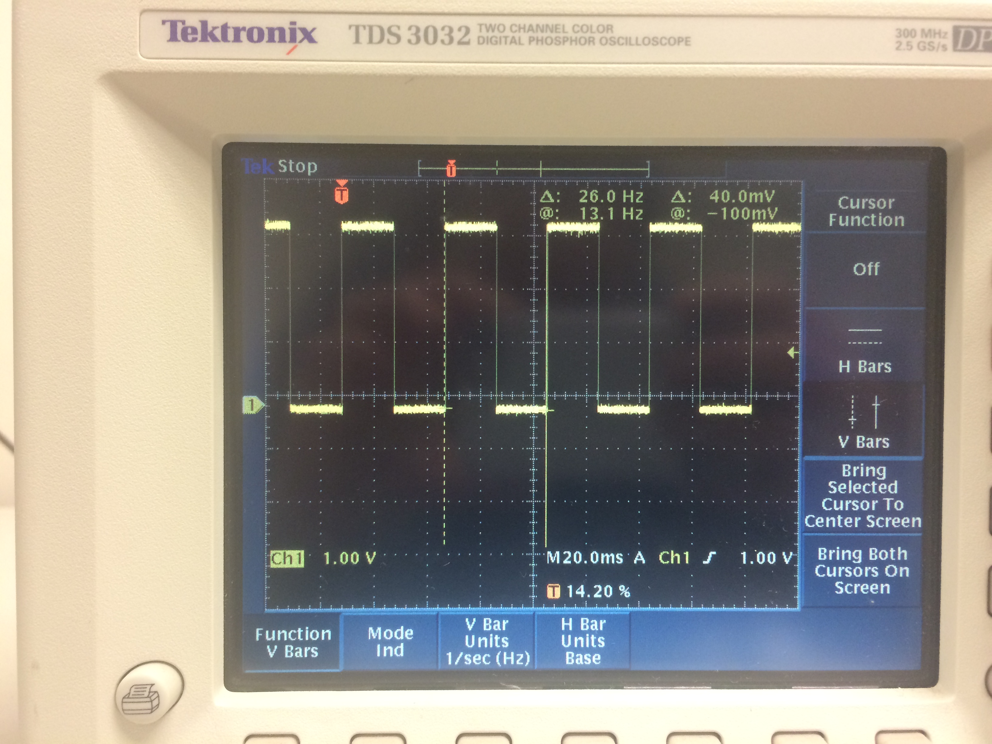

To the left is the software created square wave going at 26Hz.

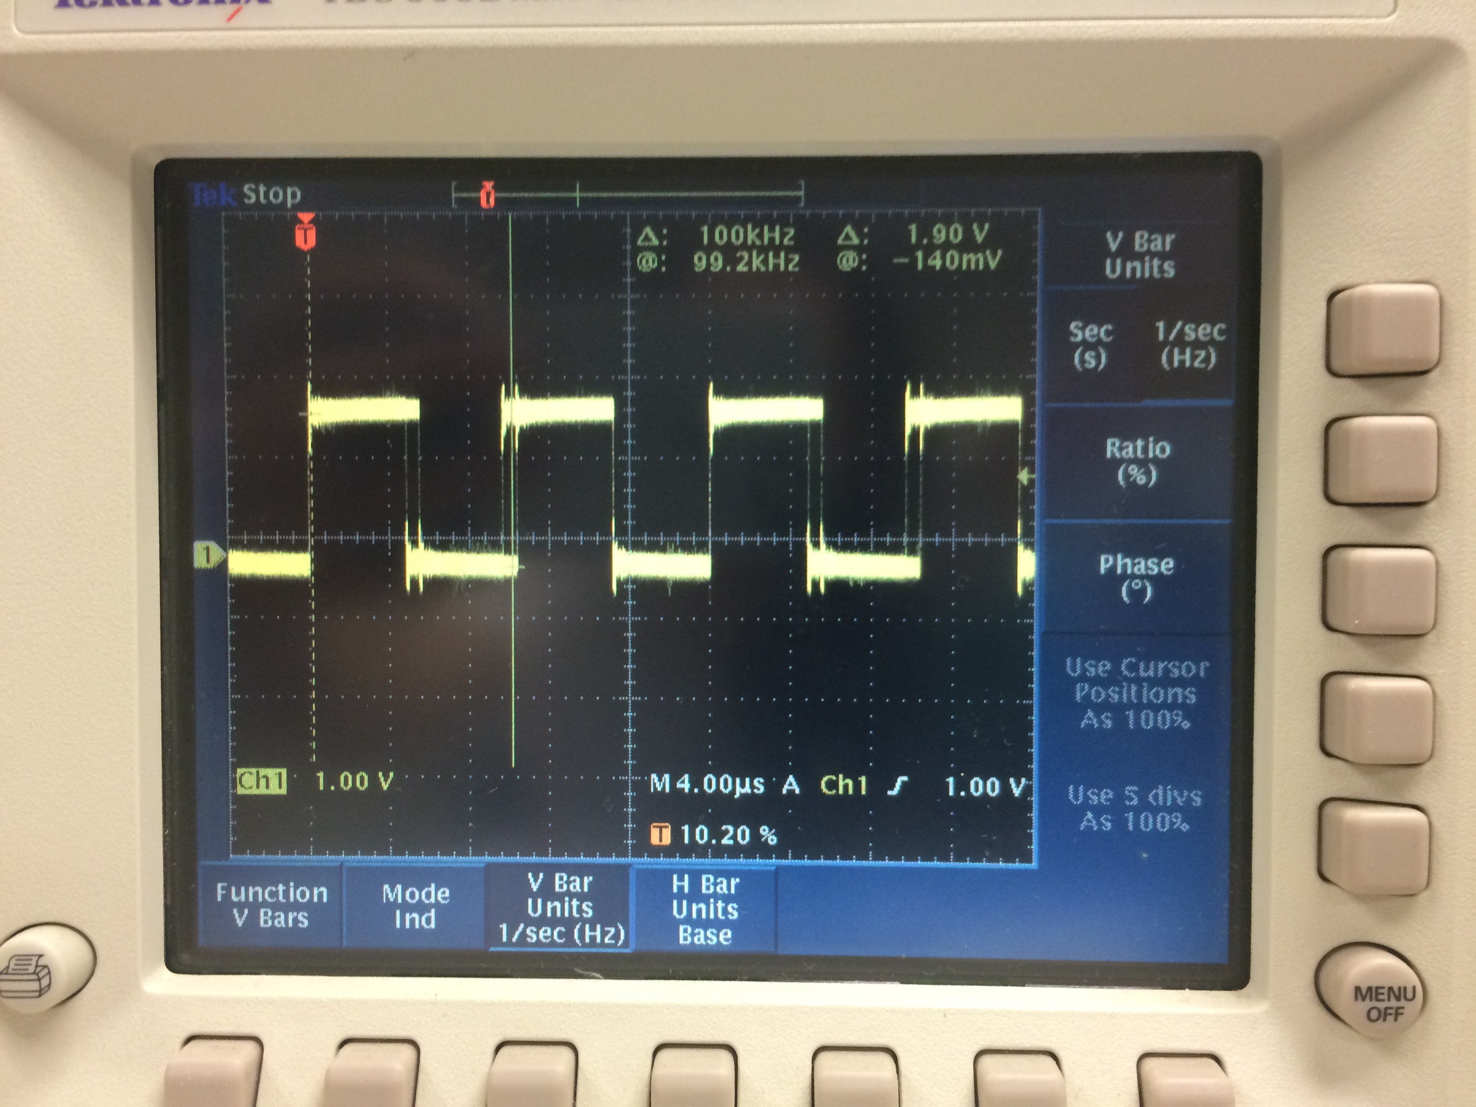

To the right is the software created square wave going at a speed of 100kHz. Note the jitter on the wave.

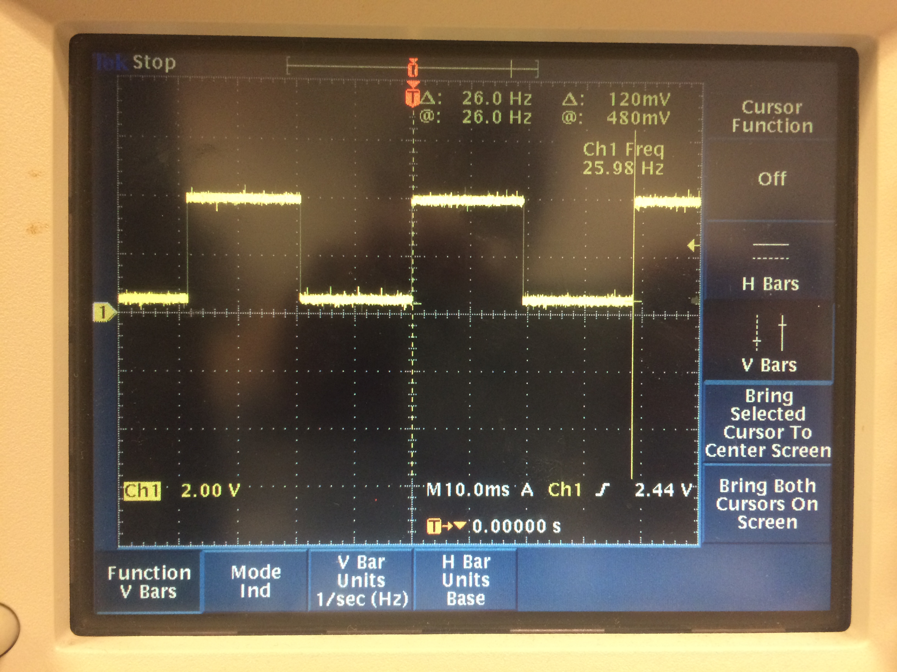

To the left is the 26Hz square wave created through the hardware

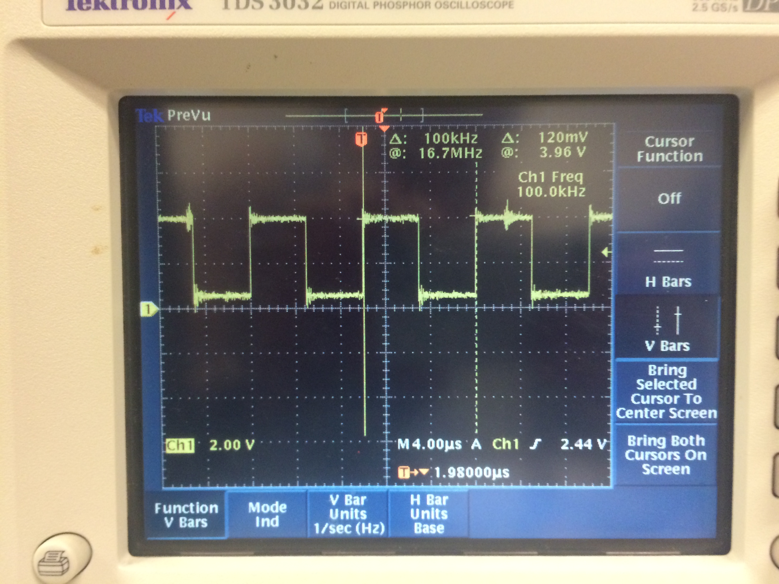To the rigth is the 100kHz square wave created by the hardware. Note the jitter on the wave.

Note the jitter which can be seen on the faster 100kHz square waves. Also, it is important to mention that we had to set the prescaler to divide by 128 for our delay time to accurately slow down the frequency on the 26Hz . The prescaler was removed for the 100kHz frequency. The code for this section can be found in the appendix.

## GPIO with the Beaglebone using C++

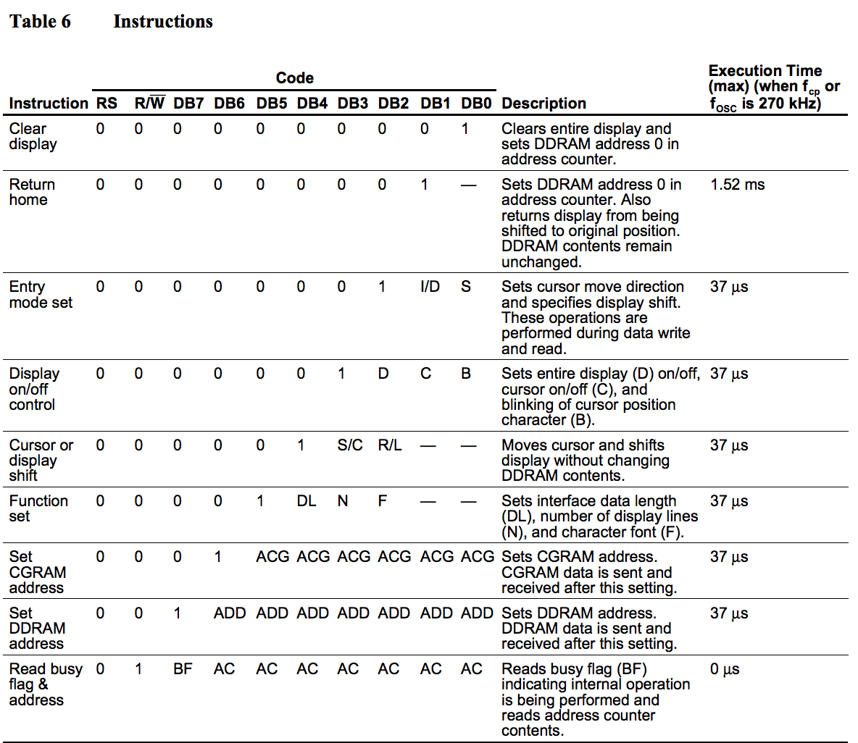 The LCD is located on the Altera DE2 board. We will create a small VHDL circuit that simple connects the LCD pins to the 40-pin header. This will allow us to control the LCD using the HCS12 microcontroller. Using interfacing information about the LCD, we will write a small piece of software that will display “Hello World” on the LCD. In order to make sure we can format the LCD screen, we will display Hello World left justified, along with showing Tatiana and GX centered on the second line. We set two P Ports and 8 AD ports for this section. We will use the timer and set it to 90 for a 49 microsecond delay, and 300 for a 1.65ms delay. This means we need to keep the prescale set to all 0’s. There are two outputs we will be coding on the Altera in VHDL, the LCD_ON and LCD_RW. Table 6 (seen right) on the LCD microcontroller’s data sheet contains the list of signals that can be used to send instructions to the LCD. We will use its 8-bit mode. The process of sending our data to the LCD is as follows: Connect power. Set function set (tells what bits to set). Display on control (set to enable). Set entry mode to 8-bits. Write data in ASCII. Set DDR address (this shifts the cursor to the second line at address 0x064 (if set to that address)). We use VHDL code with 11 inputs and 11 outputs. This will allow us to connect the 40-pin header to our LCD display. To center the 40-Pin header to out LCD display we sent the function set, display control, entry mode set, writing “Hello World”, then setting the DDR address instruction. We used 0xC4 to center our names (position) them on the second line. Our finished result can be viewed below. The code for this section can be found in the appendix.

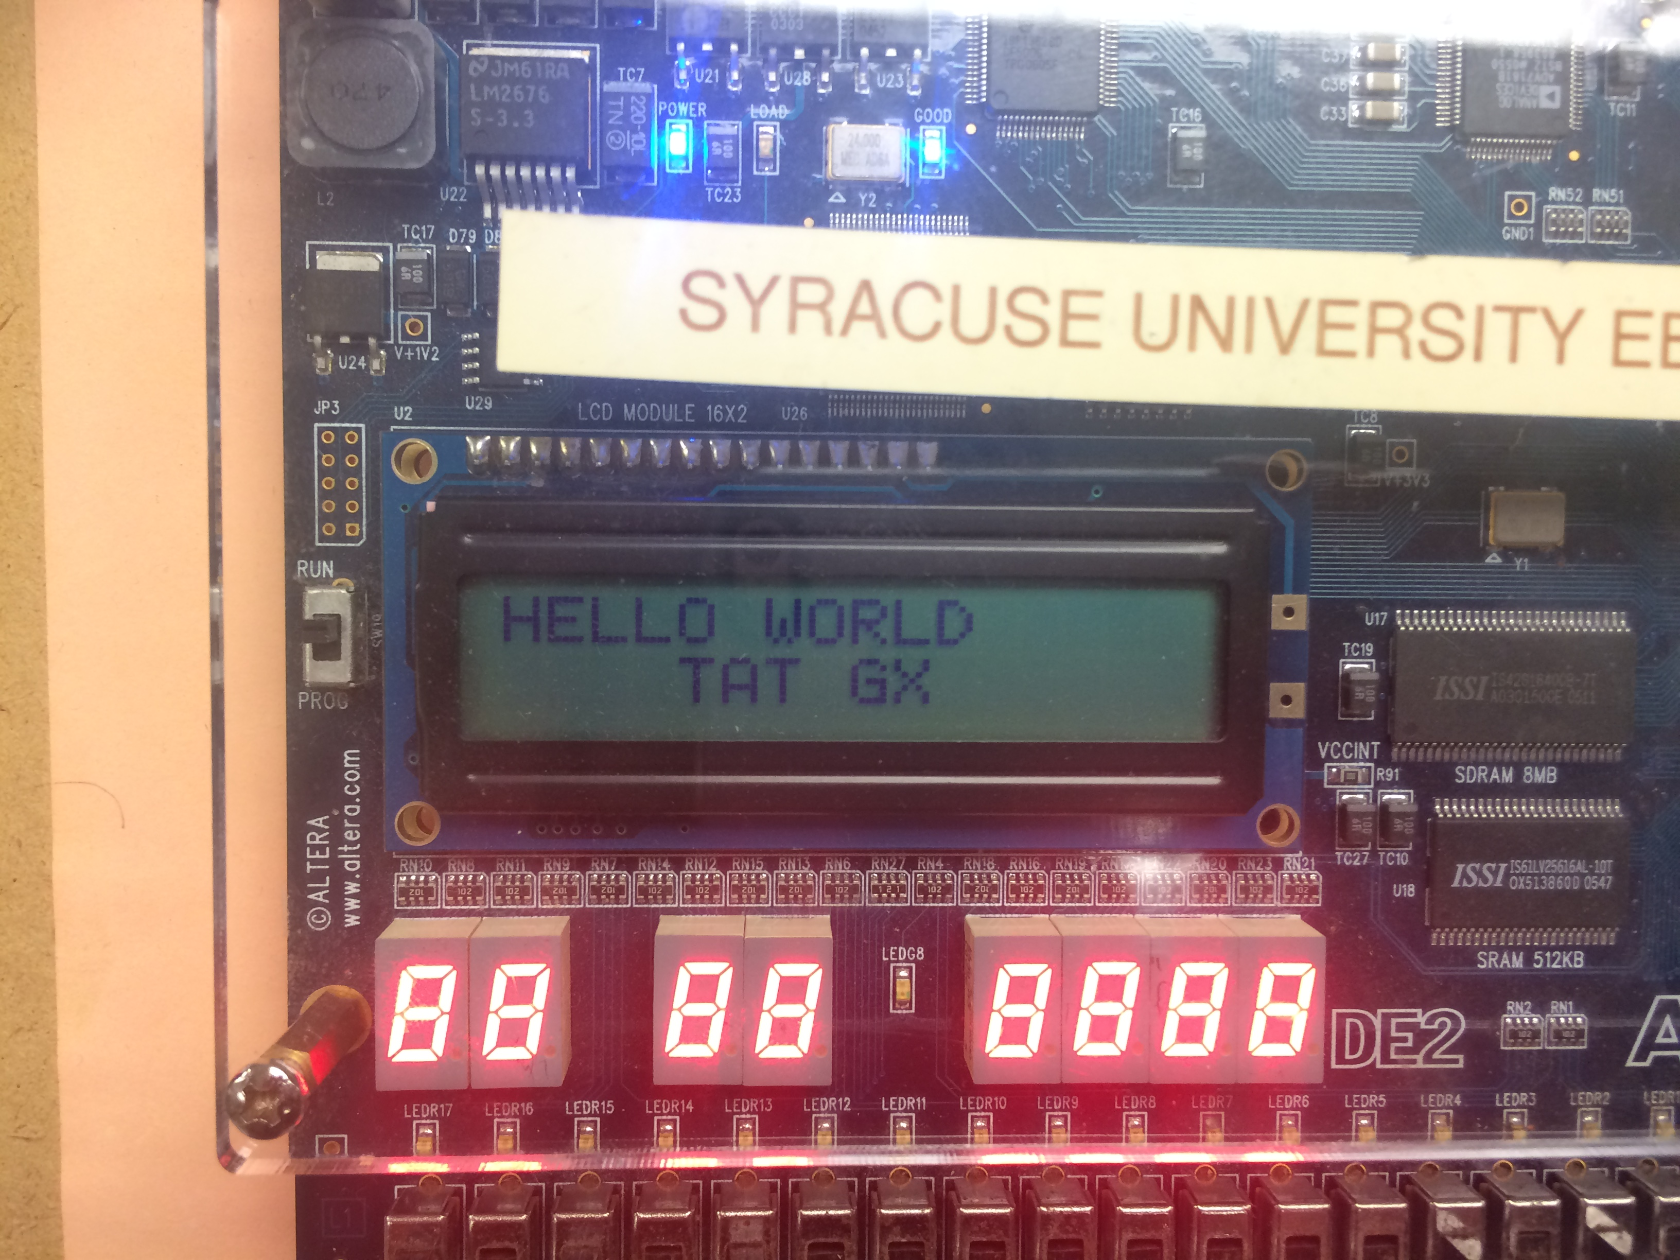

## Compare the speed of a Beaglebone GPIO to the KL05 GPIO

We were given a 4x4 keypad, which is simply 16 switches connected by 8 wires. We will create an algorithm that will implement knowing the pressed button and display it to the LCD. The back of the keypad looks like:

We will have four inputs and four outputs. We will also set a pull enable and polarity register on our ports in order for all the ports to be initialized to ‘0’. Our algorithm will register a ‘1==1,’ which will then print that selected character. We will use an 8-pin header to connect the keypad to our controller. To do this, we set OCPD (enable T ports for non-timer use) to 0xFF and use the T ports to connect the keypad. We will set our rows as out and our columns as in. T0-T3

1 2 3 A

4 5 6 B

7 8 9 C

* 0 # D

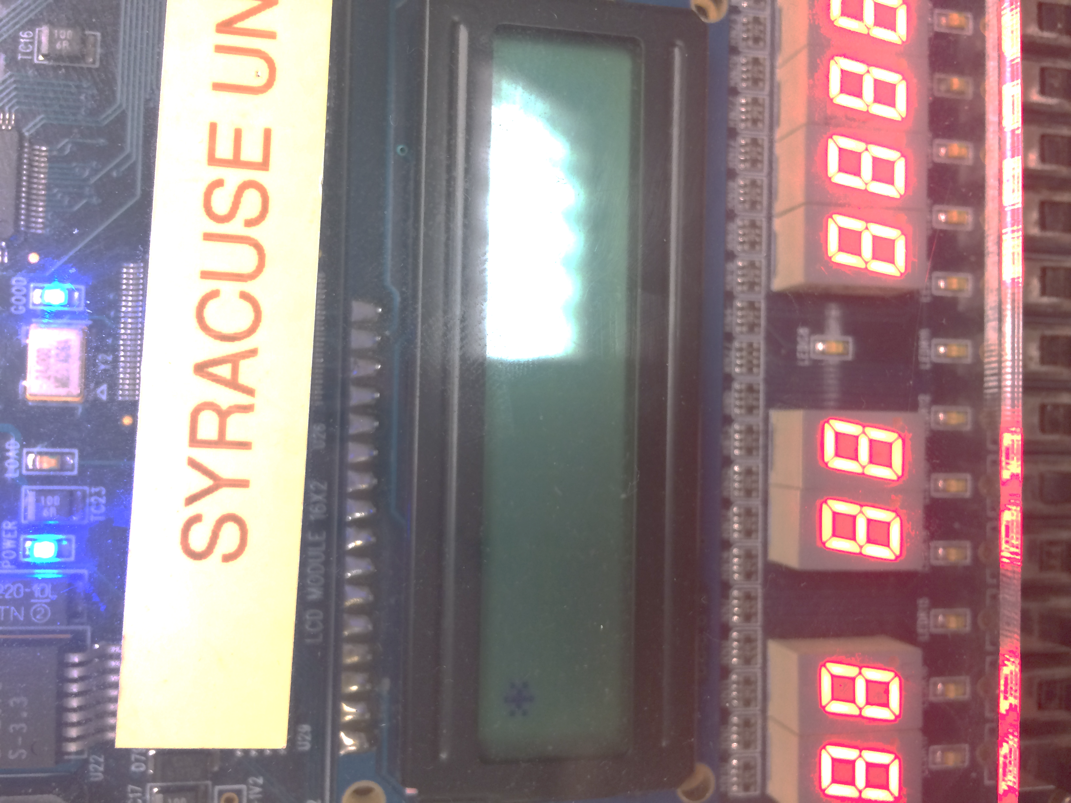are outputs and T4-T7 are our inputs. We now enable the pull registers, which will set all the T ports to ‘0.’ We also created multiple functions to clean and ease the code, such as an enable function which sets the enable bit to ‘1’ then ‘0,’ a cleardisplay function, as well as a writedata function which intakes a character to be printed out. These functions and others include a special delay calculated for the keypad between buttons. Our VHDL code remained the same from the last part. Note that in our code, we clear the LCD screen before changing to the next character. When using the keypad, the wires can have bounce, which is due to the 8 wires crossing unintentionally when a button is pressed. This can be resolved through a small delay, which allows for the full ‘1’ of the button press to be registered. The code for this section can be found in the appendix.

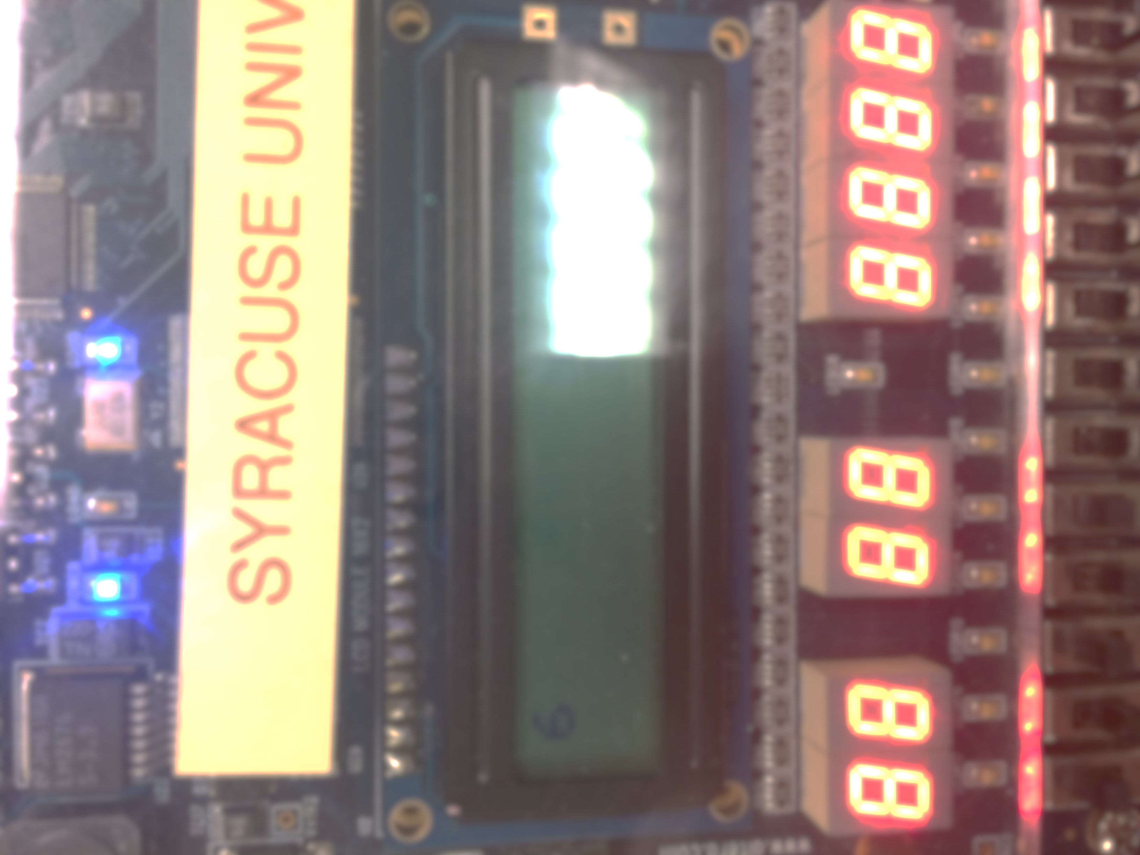

To the left are screenshots of two of the characters being displayed properly on the LCD display after being pressed on the keypad.

## GPIO Expander on the I2C Bus

For this section, leave the keypad and Altera board connected to the microcontroller. Start by programming on CodeWarrior a piece of software that will begin the game by showing “Press any key to begin” on the LCD. When a key on the keypad is pressed, the program should clear the screen and then display two of the 16-keypad buttons randomly on the first line of the LCD. The user should then press the two keys. The objective is to be able to see how ling it will take to press the two keys. This is not an Input Capture problem; timing resolution on the sub-microsecond scale is not necessary. Once the user has pressed the two keys in the proper order, the program should be able to display the time between the last character displayed on the LCD and the last character pressed on the keypad. The time should then be properly displayed the second line of the LCD to the nearest millisecond. The second line should be formatted to display “Reaction: xxx ms.” The game should then restart after a short 5 to 10 second delay.

## Using the GPIO Expander with C++ Code

For this section, leave the keypad and Altera board connected to the microcontroller. Start by programming on CodeWarrior a piece of software that will begin the game by showing “Press any key to begin” on the LCD. When a key on the keypad is pressed, the program should clear the screen and then display two of the 16-keypad buttons randomly on the first line of the LCD. The user should then press the two keys. The objective is to be able to see how ling it will take to press the two keys. This is not an Input Capture problem; timing resolution on the sub-microsecond scale is not necessary. Once the user has pressed the two keys in the proper order, the program should be able to display the time between the last character displayed on the LCD and the last character pressed on the keypad. The time should then be properly displayed the second line of the LCD to the nearest millisecond. The second line should be formatted to display “Reaction: xxx ms.” The game should then restart after a short 5 to 10 second delay.

## Detecting Analog Signals with the Beaglebone

For this section, leave the keypad and Altera board connected to the microcontroller. Start by programming on CodeWarrior a piece of software that will begin the game by showing “Press any key to begin” on the LCD. When a key on the keypad is pressed, the program should clear the screen and then display two of the 16-keypad buttons randomly on the first line of the LCD. The user should then press the two keys. The objective is to be able to see how ling it will take to press the two keys. This is not an Input Capture problem; timing resolution on the sub-microsecond scale is not necessary. Once the user has pressed the two keys in the proper order, the program should be able to display the time between the last character displayed on the LCD and the last character pressed on the keypad. The time should then be properly displayed the second line of the LCD to the nearest millisecond. The second line should be formatted to display “Reaction: xxx ms.” The game should then restart after a short 5 to 10 second delay.

## Display the Voltage and Number of Rotations on the LCD Screen

For this section, leave the keypad and Altera board connected to the microcontroller. Start by programming on CodeWarrior a piece of software that will begin the game by showing “Press any key to begin” on the LCD. When a key on the keypad is pressed, the program should clear the screen and then display two of the 16-keypad buttons randomly on the first line of the LCD. The user should then press the two keys. The objective is to be able to see how ling it will take to press the two keys. This is not an Input Capture problem; timing resolution on the sub-microsecond scale is not necessary. Once the user has pressed the two keys in the proper order, the program should be able to display the time between the last character displayed on the LCD and the last character pressed on the keypad. The time should then be properly displayed the second line of the LCD to the nearest millisecond. The second line should be formatted to display “Reaction: xxx ms.” The game should then restart after a short 5 to 10 second delay.

# Discussion

This lab has provided us with a good understanding of what a microcontroller is capable of doing through its I/O ports as well as with an I/O GPIO expander. This experiment allows one to learn how to use and navigate the GUI XLaunch in coordination with the Beaglebone Black through a mini USB. It allows one to learn the skills and commands necessary to using the command line interface. This lab also does a terrific job of testing one’s ability to use file streaming, as well as object oriented programming. The C++ code, which is implemented throughout this experiment, requires both public and private variables, getters/setters, as well as constructors and destructors. Different class files were created and implemented and certain # declarations were set in place to keep parts of the code (such as the main) safe. It was also interesting to see and note the differences between using the Beaglebone Black with GPIO’s in comparison to programming and implementing GPIO’s through the KL05, which most definitely was a bit easier, requiring only one line of code compared to our C++ class for the Beaglebone. Using a GPIO expander is incredible useful for freeing up the Beaglebone’s original I/O inputs, allowing for the creation and use of multiple other ports to be implementing, including the I2C using the device tree overlay. It is good to note that detecting an analog signal with the Beaglebone can be further implemented into a digital signal using the device tree overlay method. It is also useful that this signal (data) can be handled in multiple ways, such as displaying accurate real-time readouts on an LCD display. The most difficult part of this experiment was creating the GPIO class for the Beaglebone black. This is because we were unfamiliar with the GUI, as well as improperly implementing the requirements through system calls originally—rather than file I/O. Additionally, it was extremely frustrating to debug the code through the G++ debugger once we did have runnable code. Yet, through trial and error, we were eventually able to figure out the cause of our by using the debugging tool and properly run the necessary code.

Although we did encounter a few challenges while working through this lab, such as debugging issues, forgetting to wire a pin to ground, or improperly handling file I/O streaming by opening a file twice unintentionally, we were able to work out our problems. Through use of the datasheet, object files, and knowledge about the communication protocols for the Beaglebone black through GPIO expanders, we were able to successfully complete the experiment.

# Appendix A- GPIO with the Beaglebone using the Command Line Interface

library IEEE;

use IEEE.std_logic_1164.all;

use IEEE.std_logic_unsigned.all;

entity LCD is

port (

t0 : in std_logic;

t1 : in std_logic;

t2 : in std_logic;

t3 : in std_logic;

t4 : in std_logic;

t5 : in std_logic;

t6 : in std_logic;

t7 : in std_logic;

p0 : in std_logic;

outa : out std_logic;

outb : out std_logic;

outc : out std_logic;

outd : out std_logic;

oute : out std_logic;

outf : out std_logic;

outg : out std_logic;

outh : out std_logic;

out1 : out std_logic;

enable : in std_logic;

LCDon : out std_logic;

out2 : out std_logic;

out3 : out std_logic

);

end entity;

architecture behave of LCD is

BEGIN

LCDon <= '1';

out3 <= enable; --P1

out1 <= p0; --RS

out2 <= '0'; --rw

outa <= t0; --hex byte

outb <= t1;

outc <= t2;

outd <= t3;

oute <= t4;

outf <= t5;

outg <= t6;

outh <= t7;

end architecture;

# Appendix B – GPIO with the Beaglebone Using C++

Library IEEE;

use IEEE.std_logic_1164.all;

entity gpio_test is

port

(

gpio_in_led_1 :in std_logic;

gpio_in_led_2 :in std_logic;

gpio_in_led_3 :in std_logic;

gpio_in_led_4 :in std_logic;

gpio_out_led_1 : out std_logic;

gpio_out_led_2 : out std_logic;

gpio_out_led_3 : out std_logic;

gpio_out_led_4 : out std_logic;

gpio_in_switch_1 :in std_logic;

gpio_in_switch_2 :in std_logic;

gpio_in_switch_3 :in std_logic;

gpio_in_switch_4 :in std_logic;

gpio_out_switch_1 : out std_logic;

gpio_out_switch_2 : out std_logic;

gpio_out_switch_3 : out std_logic;

gpio_out_switch_4 : out std_logic

);

end gpio_test;

architecture test of gpio_test is

begin

gpio_out_led_1 <= gpio_in_led_1;

gpio_out_led_2 <= gpio_in_led_2;

gpio_out_led_3 <= gpio_in_led_3;

gpio_out_led_4 <= gpio_in_led_4;

gpio_out_switch_1 <= gpio_in_switch_1;

gpio_out_switch_2 <= gpio_in_switch_2;

gpio_out_switch_3 <= gpio_in_switch_3;

gpio_out_switch_4 <= gpio_in_switch_4;

end test;

GPIO CLASS CODE (.h):

#ifndef BBBCEKGPIO_H

#define BBBCEKGPIO_H

class GPIO{

private:

int value;

int pinNum;

char* direction;

public:

//Constructors

GPIO();

~GPIO();

GPIO(int p, int v, char* d);

void exportPin();

//Setters and getters

int getValue();

int getPin();

char* getDirection();

void setPin(int p);

void setValue(int v);

void setDirection(char* d);

};

#endif

GPIO CLASS CODE (.cpp):

#include "gpio.h"

#include <string>

#include <cstdio>

#include <cstring>

#include <stdlib.h>

#include <iostream>

#include <fstream>

//Default constructor

GPIO::GPIO()

{

value = 0;

direction = new char(0);

pinNum = 0;

}

//Deconstructor

GPIO::~GPIO()

{

std::ofstream myFile;

myFile.open("/sys/class/gpio/unexport");

myFile<<getPin();

myFile.close();

}

//Constructor with arguments that automatically exports and sets values

GPIO::GPIO(int p, int v, char* d)

{

setPin(p);

setDirection(d);

setValue(v);

}

//Writes to the export file the pin number

void

GPIO::exportPin()

{

std::ofstream myFile;

myFile.open("/sys/class/gpio/export");

myFile<<getPin();

myFile.close();

}

int

GPIO::getValue()

{

std::fstream myFile;

char buf[50];

sprintf(buf, "/sys/class/gpio/gpio%d/value",getPin());

myFile.open(buf);

if (myFile.is_open())

{

while ( myFile.eof() == false )

{

myFile >> value;

}

myFile.close();

}

return value;

}

char*

GPIO::getDirection()

{

return direction;

}

int

GPIO::getPin()

{

return pinNum;

}

//Sets p to pinNum and exports the pin by calling the exportPin() func

void

GPIO::setPin(int p)

{

pinNum = p;

exportPin();

}

//Sets value by writing the given v to the value file

void

GPIO::setValue(int v)

{

std::ofstream myFile;

char buf[50];

sprintf(buf, "/sys/class/gpio/gpio%d/value",getPin());

myFile.open(buf);

myFile<<v;

myFile.close();

value = v;

}

//Sets direction by writing either in or out to the direction file

void

GPIO::setDirection(char* d)

{

std::ofstream myFile;

char buf[50];

sprintf(buf, "/sys/class/gpio/gpio%d/direction",getPin());

myFile.open(buf);

myFile<<d;

myFile.close();

direction = new char(strlen(d));

strcpy(direction, d);

}

//Creates two inputs and two output GPIO objects

#ifdef TEST_GPIO

int

main(int argc, char **argv)

{

char* buffer_out= "out";

char* buffer_in= "in";

GPIO pinA(73,0,buffer_out);

GPIO pinB(74,0,buffer_out);

GPIO pinC(69,0,buffer_out);

GPIO pinD(51,0,buffer_out);

GPIO pinE(112,0,buffer_in);

GPIO pinF(110,0,buffer_in);

GPIO pinG(113,0,buffer_in);

GPIO pinH(111,0,buffer_in);

while(1){

pinA.setValue(pinE.getValue());

pinB.setValue(pinF.getValue());

pinC.setValue(pinG.getValue());

pinD.setValue(pinH.getValue());

}

return 0;

}

#endif

#ifdef TEST_DECONSTRUCT

int

main(int argc, char **argv)

{

char* buffer_out= "out";

char* buffer_in= "in";

GPIO pinA(73,0,buffer_out);

GPIO pinB(74,0,buffer_out);

GPIO pinC(69,0,buffer_out);

GPIO pinD(51,0,buffer_out);

GPIO pinE(112,0,buffer_in);

GPIO pinF(110,0,buffer_in);

GPIO pinG(113,0,buffer_in);

GPIO pinH(111,0,buffer_in);

return 0;

}

#endif

# Appendix C – Interfacing a Keypad

#include <hidef.h> /* common defines and macros */

#include "derivative.h" /* derivative-specific definitions */

void enable();

void writeData(unsigned char letter);

void clearDisplay();

void Delay();

void main(void) {

// port initializations

DDR1AD0=0xFF;

DDRM_DDRM2=1;

DDRM_DDRM3=1;

DDRT=0xF0; //set t0-t3 as inputs and t4-t7 as outputs

PERT = 0x0F; //set the pull enable all to 0

PPST = 0x0F; //polarity

OCPD=0xFF; //enable T ports as i/o

//Timer Initializations

TIOS=0xFF;

TCTL2=0x10;

TSCR1_TEN=1;

TSCR1_TFFCA=1;

TSCR2=0x03;

//send beginning instructions

clearDisplay();

while(!TFLG1_C0F){}

TC0=TCNT + 300; //49microsecond delay

//functon set

PT1AD0 = 0x3F;

PTM_PTM3 = 0;

enable();

TC0=TCNT + 300; //49mic delay

while(!TFLG1_C0F){}

//display on

PT1AD0 = 0x0E;PTM_PTM3 = 0;

enable();

TC0=TCNT + 300; //49mic delay

while(!TFLG1_C0F){}

//entry mode

PT1AD0 = 0x06;

PTM_PTM3 = 0;

enable();

TC0=TCNT + 300; //49mic delay

while(!TFLG1_C0F){}

TC0=TCNT + 300; //49mic delay

while(!TFLG1_C0F){}

// end beginning instructions

//=================================================================

//algorithm to recognize letter

int i =0;

for(;;){

for(int i = 0; i <4; i++){

if(i==0){

PTT_PTT4=1;

PTT_PTT5=0;

PTT_PTT6=0;

PTT_PTT7=0;

Delay();

if(PTT_PTT0==1) {

clearDisplay();

writeData(0x44); //1

}

Delay();

if(PTT_PTT1==1) {

clearDisplay();

writeData(0x23); //4

}

Delay();

if(PTT_PTT2==1) {

clearDisplay();

writeData(0x30); //7

}

Delay();

if(PTT_PTT3==1) {

clearDisplay();

writeData(0x2A); //x

}

Delay();

}

if(i==1){

PTT_PTT4=0;

PTT_PTT5=1;

PTT_PTT6=0;

PTT_PTT7=0;

if(PTT_PTT0==1) {

clearDisplay();

writeData(0x43);//send 2

}

if(PTT_PTT1==1) {

clearDisplay();

writeData(0x39);//send5

}

if(PTT_PTT2==1) {

clearDisplay();

writeData(0x38);//send8

}

if(PTT_PTT3==1) {

clearDisplay();

writeData(0x37); //send 0

}

}

if(i==2){

PTT_PTT4=0;

PTT_PTT5=0;

PTT_PTT6=1;

PTT_PTT7=0;

if(PTT_PTT0==1) {

clearDisplay();

writeData(0x42);//send 3

}

if(PTT_PTT1==1) {

clearDisplay();

writeData(0x36); //send6

}

if(PTT_PTT2==1) {

clearDisplay();

writeData(0x35);//send9

}

if(PTT_PTT3==1) {

clearDisplay();

writeData(0x34);//send #

}

}

if(i==3){

PTT_PTT4=0;

PTT_PTT5=0;

PTT_PTT6=0;

PTT_PTT7=1;

Delay();

if(PTT_PTT0==1) {

clearDisplay();

writeData(0x41);//send A

}

Delay();

if(PTT_PTT1==1) {

clearDisplay();

writeData(0x33);//sendB

}

if(PTT_PTT2==1) {

clearDisplay();

writeData(0x32);//sendC

}

if(PTT_PTT3==1) {

clearDisplay();

writeData(0x31);//send D

}

}

}

}

}

void clearDisplay(){

TC0=TCNT + 300; //49mic delay

while(!TFLG1_C0F){}

//clear screen

PT1AD0=0X01;//CLEAR DISPLAY

PTM_PTM3=0; // RS

PTM_PTM2=1; // SELECT DATA

PTM_PTM2=0;

}

void enable(){

PTM_PTM2 = 1; //this is the enable for the LCD

PTM_PTM2 = 0; //this is the enable for the LCD

}

void writeData(unsigned char letter){

TSCR2_PR0=0;

TSCR2_PR1=1;

TSCR2_PR2=0;

TC0=TCNT + 6760; //49mic delay

while(!TFLG1_C0F){}

//write data

PTM_PTM3 = 1;

PT1AD0 = letter;

enable();

}

void Delay(){

TSCR2_PR0=0;

TSCR2_PR1=1;

TSCR2_PR2=1;

TC0=TCNT + 0x2497; //delay

while(!TFLG1_C0F){}

}

# Appendix D – Reaction Game

#include <hidef.h> /* common defines and macros */

#include "derivative.h" /* derivative-specific definitions */

void enable();

void writeData(unsigned char letter);

void clearDisplay();

void Delay();

void reposition(unsigned char position); //set DDgram

void writeData2(unsigned char letter);

void run();

void welcome();

void sendInitInstructions();

void generateSecretNumbers();

//void pressAnyButton(); //begins game

void findButton(); //finds and prints when a button is pressed

int num;

int num2;

unsigned char symbols[16]={0x31,0x32,0x33,0x34,0x35,0x36,0x37,0x38,0x39,0x30,0x2A,0x23,0x41,0x42,0x43,0x44};

unsigned char answer1;

unsigned long int time1;

unsigned long int time2;

unsigned long int reactionTime;

unsigned long int a,b,c,d;

void main(void) {

// port initializations

DDR1AD0=0xFF;

DDRM_DDRM2=1;

DDRM_DDRM3=1;

DDRT=0xF0; //set t0-t3 as inputs and t4-t7 as outputs

PERT = 0x0F; //set the pull enable all to 0

PPST = 0x0F; //polarity

OCPD=0xFF; //enable T ports as i/o

//Timer Initializations

TIOS=0xFF;

TCTL2=0x10;

TSCR1_TEN=1;

TSCR1_TFFCA=1;

TSCR2=0x03;

//send beginning instructions

sendInitInstructions();

/* generate secret number between 1 and 10: */

generateSecretNumbers();

//Welcome the player to the game

welcome();

//pressAnyButton();

for (int k; k<5000; k++){

PTT_PTT4=1;

if (PTT_PTT0 == 1 && PTT_PTT4 == 1)

run();

}

//start timer here

time1= TCNT;

findButton();

}

//============================end of main====================================//

void run(){

clearDisplay();

writeData(symbols[num]);

writeData(symbols[num2]);

}

void clearDisplay(){

TC0=TCNT + 300; //49mic delay

while(!TFLG1_C0F){}

//clear screen

PT1AD0=0X01;//CLEAR DISPLAY

PTM_PTM3=0; // RS

PTM_PTM2=1; // SELECT DATA

PTM_PTM2=0;

}

void enable(){

PTM_PTM2 = 1; //this is the enable for the LCD

PTM_PTM2 = 0; //this is the enable for the LCD

}

void writeData(unsigned char letter){

TSCR2_PR0=0;

TSCR2_PR1=1;

TSCR2_PR2=0;

TC0=TCNT + 6760; //49mic delay

while(!TFLG1_C0F){}

//write data

PTM_PTM3 = 1;

PT1AD0 = letter;

enable();

}

void Delay(){

TSCR2_PR0=0;

TSCR2_PR1=1;

TSCR2_PR2=1;

TC0=TCNT + 0x2497; //delay

while(!TFLG1_C0F){}

}

void reposition(unsigned char position){

TSCR2_PR0=0;

TSCR2_PR1=1;

TSCR2_PR2=0;

TC0=TCNT + 6760; //49mic delay

while(!TFLG1_C0F){}

PT1AD0 = position; //set to 1st line far left

PTM_PTM3 = 0;

enable();

}

void writeData2(unsigned char letter){

if(letter == symbols[num]){

answer1 = letter;

return;

}

if(answer1 == symbols[num]){

if (letter == symbols[num2]){

//end counter

time2=TCNT;

reactionTime = time2-time1;

reactionTime = reactionTime * 1000; // convert clock cycles to seconds

reactionTime = reactionTime/46875;

a = reactionTime % 10; // convert number to single byte

reactionTime/=10;

b = reactionTime % 10;

reactionTime/=10;

c = reactionTime % 10;

reactionTime/=10;

d = reactionTime % 10;

reposition(0xC2);

writeData(0x52);//R

writeData(0x65);//e

writeData(0x61);//a

writeData(0x63); //c

writeData(0x74);//t

writeData(0x69);//i

writeData(0x6F);//o

writeData(0x6E);//n

writeData(0x3A);//:

writeData(0x20);// #+0x30 convert to ascii

writeData(d); //send single byte

writeData(c);

writeData(b);

writeData(a);

}

}

}

void welcome(){

writeData(0x50);//P

writeData(0x72);//r

writeData(0x65);//e

writeData(0x73);//s

writeData(0x73);//s

writeData(0x20);//

writeData(0x41);//A

writeData(0x6E);//n

writeData(0x79);//y

writeData(0x20);//

writeData(0x4B);//K

writeData(0x65);//e

writeData(0x79);//y

writeData(0x20);//

writeData(0x54);//T

writeData(0x6F);//o

reposition(0xC6);//next line

writeData(0x42);//B

writeData(0x65);//e

writeData(0x67);//g

writeData(0x69);//i

writeData(0x6E);//n

}

void sendInitInstructions(){

TSCR2=0x03;

clearDisplay();

while(!TFLG1_C0F){}

TC0=TCNT + 300; //49microsecond delay

//functon set

PT1AD0 = 0x3F;

PTM_PTM3 = 0;

enable();

TC0=TCNT + 300; //49mic delay

while(!TFLG1_C0F){}

//display on

PT1AD0 = 0x0E;PTM_PTM3 = 0;

enable();

TC0=TCNT + 300; //49mic delay

while(!TFLG1_C0F){}

//entry mode

PT1AD0 = 0x06;

PTM_PTM3 = 0;

enable();

TC0=TCNT + 300; //49mic delay

while(!TFLG1_C0F){}

TC0=TCNT + 300; //49mic delay

while(!TFLG1_C0F){}

}

void generateSecretNumbers(){

num = TC0 % 16;

while(!TFLG1_C0F){}

TC0=TCNT + 300; //49mic delay

num2 = (TC0 +30) %16;

}

void findButton(){

TSCR2=0x07;

for(;;) {

for(int i = 0; i <4; i++){

PTT_PTT4=0;

PTT_PTT5=0;

PTT_PTT6=0;

PTT_PTT7=0;

if(i==0){

PTT_PTT4=1;

Delay();

if(PTT_PTT0==1) {

writeData2(0x44);

}

Delay();

if(PTT_PTT1==1) {

writeData2(0x23);

}

Delay();

if(PTT_PTT2==1) {

writeData2(0x30);

}

Delay();

if(PTT_PTT3==1) {

writeData2(0x2A);

}

Delay();

}

if(i==1){

PTT_PTT5=1;

if(PTT_PTT0==1) {

writeData2(0x43);

}

if(PTT_PTT1==1) {

writeData2(0x39);

}

if(PTT_PTT2==1) {

writeData2(0x38);

}

if(PTT_PTT3==1) {

writeData2(0x37);

}

}

if(i==2){

PTT_PTT6=1;

if(PTT_PTT0==1) {

writeData2(0x42);

}

if(PTT_PTT1==1) {

writeData2(0x36);

}

if(PTT_PTT2==1) {

writeData2(0x35);

}

if(PTT_PTT3==1) {

writeData2(0x34);

}

}

if(i==3){

PTT_PTT7=1;

Delay();

if(PTT_PTT0==1) {

writeData2(0x41);

}

Delay();

if(PTT_PTT1==1) {

writeData2(0x33);

}

if(PTT_PTT2==1) {

writeData2(0x32);

}

if(PTT_PTT3==1) {

writeData2(0x31);

}

}

}

}

}